**PRACTICAL NO. 2**

**Task 2: Virtualization, Installation of virtual machine software and installation of operating system on virtual machine.**

**Virtualization:** Virtualization is a technology that creates virtual versions of physical hardware, operating systems, and other resources. Virtualization allows users to run multiple virtual machines (VMs) on a single physical machine.

**Features of virtualization:**

* **Resource isolation:**Operating system-based virtualization provides a high level of resource isolation, which allows each container to have its own set of resources, including CPU, memory, and I/O bandwidth.
* **Lightweight:**Containers are lightweight compared to traditional virtual machines as they share the same host operating system, resulting in faster startup and lower resource usage.
* **Portability:** Containers are highly portable, making it easy to move them from one environment to another without needing to modify the underlying application.
* **Scalability:** Containers can be easily scaled up or down based on the application requirements, allowing applications to be highly responsive to changes in demand.
* **Security:**Containers provide a high level of security by isolating the containerized application from the host operating system and other containers running on the same system.
* **Reduced Overhead:**Containers incur less overhead than traditional virtual machines, as they do not need to emulate a full hardware environment.
* **Easy Management:**Containers are easy to manage, as they can be started, stopped, and monitored using simple commands.

**Linux operating system:** The Linux Operating System is a type of operating system that is like Unix, and it is built upon the Linux Kernel. The Linux Kernel is like the brain of the operating system because it manages how the computer interacts with its hardware and resources. It makes sure everything works smoothly and efficiently. But the Linux Kernel alone is not enough to make a complete operating system. To create a full and functional system, the Linux Kernel is combined with a collection of software packages and utilities, which are together called Linux distributions. These distributions make the Linux Operating System ready for users to run their applications and perform tasks on their computers securely and effectively. Linux distributions come in different flavours, each tailored to suit the specific needs and preferences of users.

**Linux distributions:**

1. **Ubuntu:**

* **Audience:** Beginners and general users.
* **Why it’s popular**: Ubuntu is one of the most widely used Linux distributions, especially for beginners. It’s user-friendly and has a large community, which means help is easy to find. It’s also supported by most software vendors.
* **Features:** Easy installation, long-term support (LTS) versions, and a large software repository

1. **Debian:**

* **Audience:** Advanced users and developers
* **Why it’s popular:** Debian is known for its stability and is often used as the base for other distros, like Ubuntu. It’s a great choice for those who want a solid, secure system and don’t need the latest bleeding-edge features.
* **Features:** Reliable, secure, and versatile.

1. **Mint:**

* **Audience:** Beginners and those transitioning from Windows
* **Why it’s popular:** Linux Mint is an easy-to-use distribution that looks and feels like Windows. It’s a good choice for users who are new to Linux and want something familiar.
* **Features:** Simple, user-friendly, and ready-**to-use out of the box.**

**Minimum hardware requirements of kali Linux:** The minimum hardware requirements for Kali Linux include:

**Hard disk space:** At least 20 GB for installation, but the exact amount depends on the version.

**RAM:** At least 2 GB for i386 and AMD64 architectures

**Processor:** At least an Intel Core i3 or an AMD E1 processor

**Bootable media:** A CD-DVD drive, USB stick, or other bootable media

**Virtual box:**

Oracle VM VirtualBox is a virtualization software that lets users run multiple operating systems on a single device. It's a cross-platform software that can be installed on Windows, Linux, Mac OS X, and Solaris x86.

**Steps of installation of virtual box:**

**Step 1: Open the VirtualBox website:** Go to https://www.virtualbox.org/ in your computer's Internet browser. This is the website from which you'll download the VirtualBox setup file.

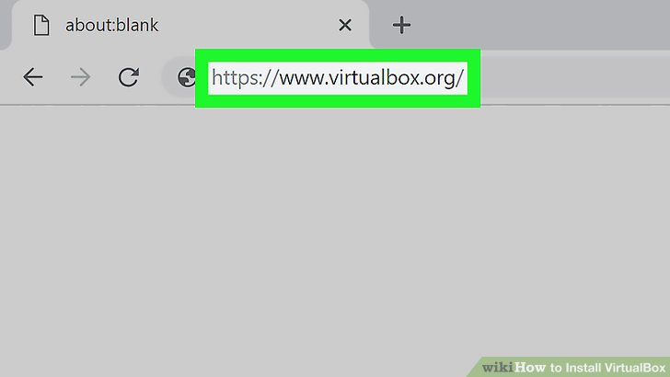

**Fig 1:** **Open the VirtualBox website.**

**Step 2: Click Download VirtualBox:** It's a blue button in the middle of the page. Doing so will open the downloads page.

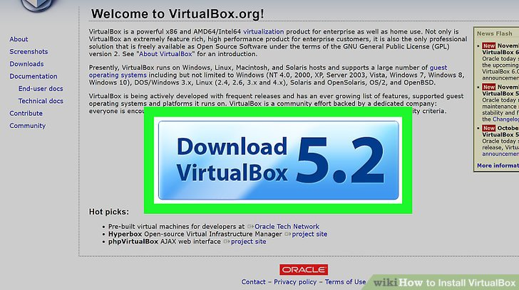

**Fig 2:** **Click Download VirtualBox.**

**Step 3: Click Windows hosts**: You'll see this link below the "VirtualBox 6.1.14 platform packages" heading. The VirtualBox EXE file will begin downloading onto your computer.

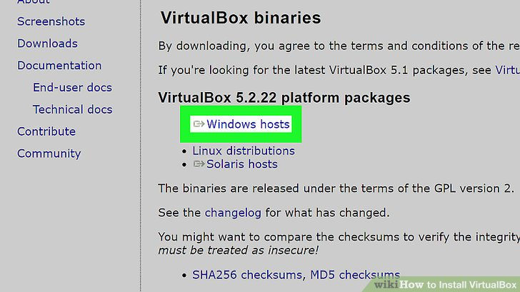

**Fig 3: Click Windows hosts.**

**Step 4: Open the VirtualBox EXE file:** Go to the location to which the EXE file downloaded and double-click the file. Doing so will open the VirtualBox installation window.

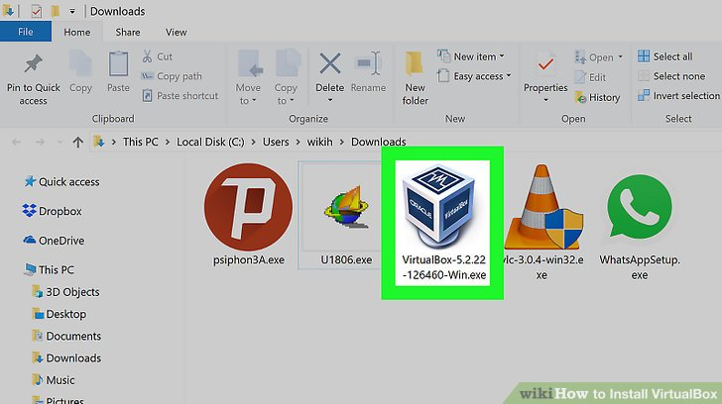

**Fig 4: Open the VirtualBox EXE file.**

**Step 5: Navigate through the installation prompts:** Do the following:

* Click Next on the first three pages.
* Click Yes when prompted.
* Click Install
* Click Yes when prompted.

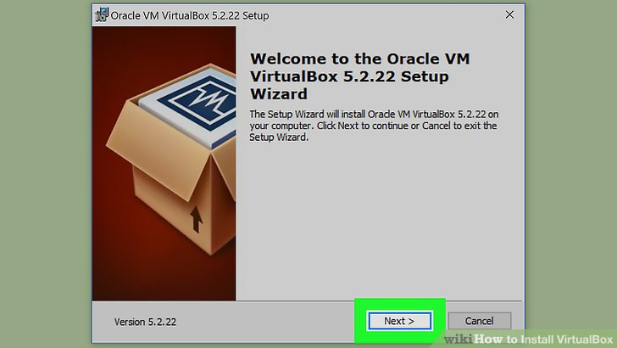

**Fig 5: Navigate through the installation prompts.**

**Step 6: Click Install when prompted:** Doing so will allow VirtualBox to begin installing on your computer.

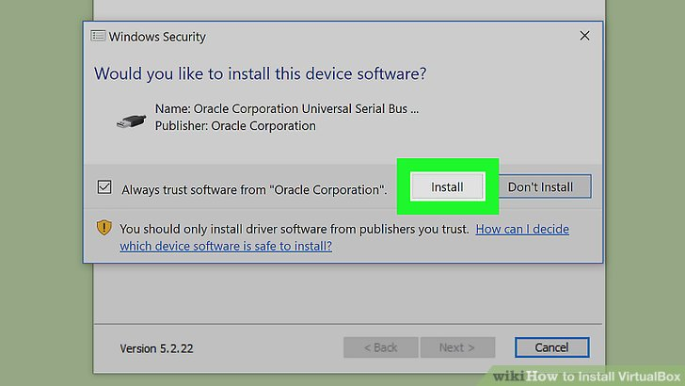

**Fig 6: Click Install when prompted.**

**Step 7: Click Finish when prompted:** It's in the lower-right side of the window. Doing so will close the installation window and open VirtualBox. Now that you've installed and opened VirtualBox, you can create a virtual machine to run any operating system on your PC.

* Make sure that you don't uncheck the "Start" box before doing this.

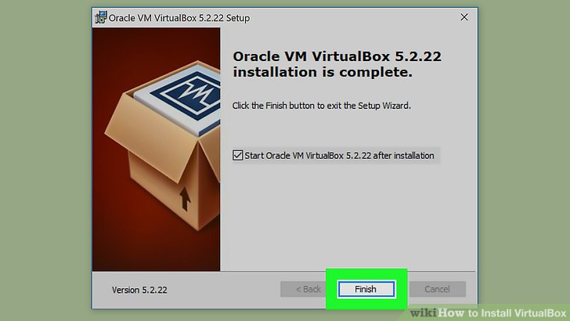

**Fig 7: Click Finish when prompted.**

**Step 8:** When you open virtual box it will look like as shown below:

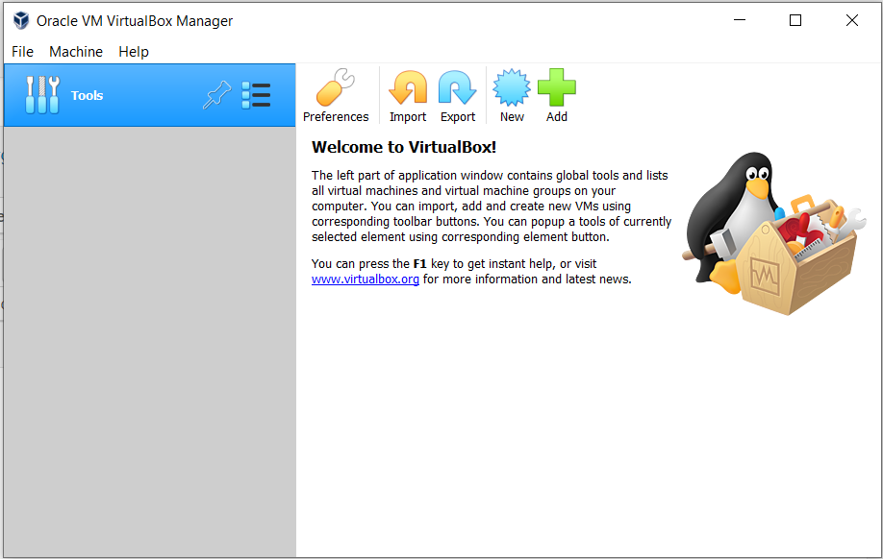

**Fig 8: Virtual box.**

**Step to install Linux operating system by using virtualization:**

**Step 1: Download Kali Linux ISO Image:**

Kali Linux offers ISO images for 32-bit, 64-bit, and ARM64 architectures. To download an ISO file:

(a) Visit the installer section of the Kali Linux official website.

(b)Select the system architecture of the host OS and download the ISO file by clicking the button in the bottom-left corner of the installer card.

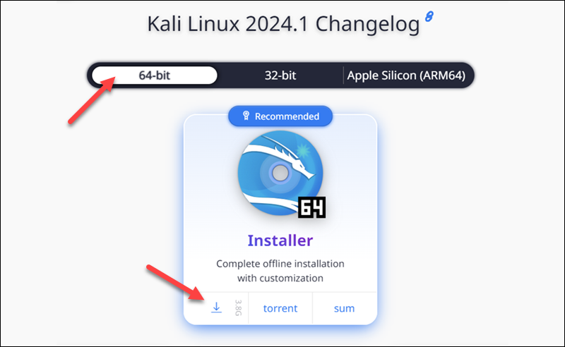

**Fig 1: Download Kali Linux ISO Image.**

**Step 2:  Create Kali Linux VirtualBox Instance**

Create a new virtual machine and configure it to run Kali Linux. Proceed with the steps below to correctly set up a Kali Linux VM in VirtualBox:

(a)Launch **VirtualBox Manager** and click the **new** icon.

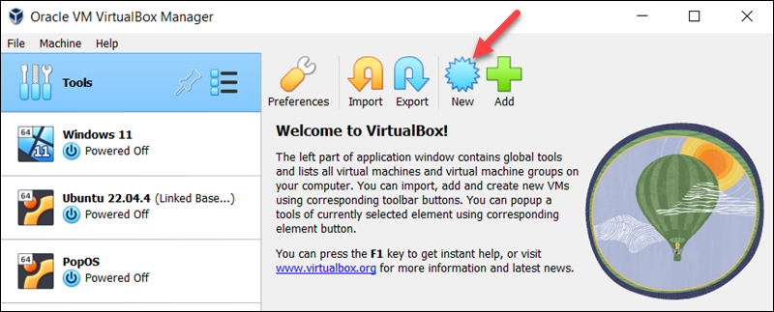

**Fig 2(a)**

(b) Specify a name for the VM and provide the path to the ISO image. Select **Next**.

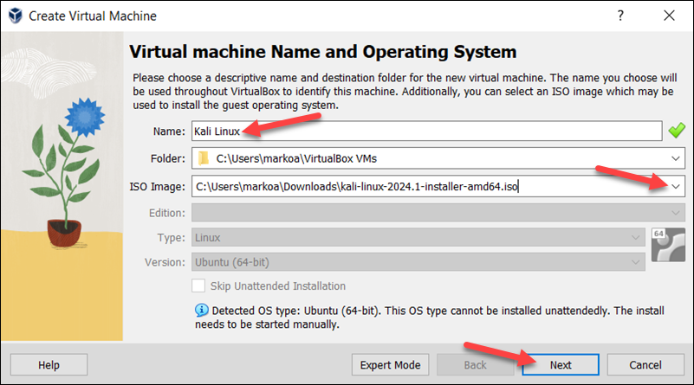

**Fig 2(b)**

(c)Select the amount of memory and the number of [**virtual CPUs**](https://phoenixnap.com/kb/what-is-a-vcpu) to allocate to the VM. The minimum recommended values for Kali Linux are **2 GB of RAM** and **1 CPU**. Select **Next** when you finish setting up the VM hardware.

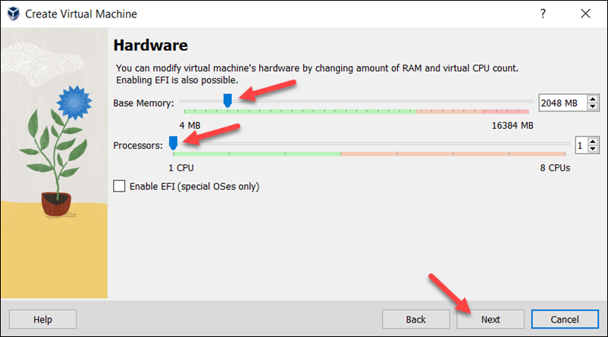

**Fig 2(c)**

(d)Create a virtual hard disk for the new VM. The recommended hard disk size is at least **25 GB**. Alternatively, you can use an existing virtual hard disk file or decide not to add one. Click **Next** to proceed to the next step.

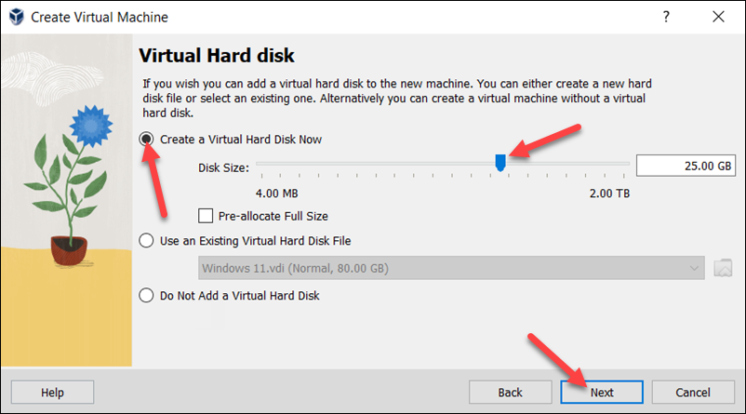

**Fig 2(d)**

(e)Review the new VM setup on the **Summary** page. Select **Finish** to create the virtual machine.

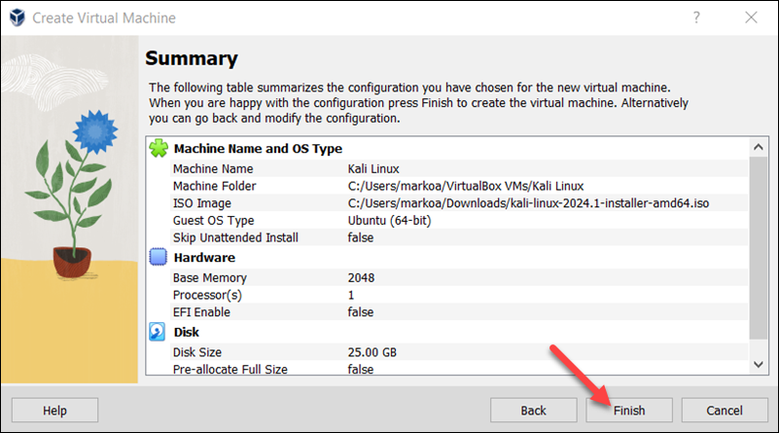

**Fig 2(e)**

**Step 3: Configure Virtual Machine Settings and Start VM**

Before starting the VM and beginning the installation process, follow the steps below to perform additional adjustments on the VM:

(a) Select the Kali Linux VM and click the **Settings icon**.

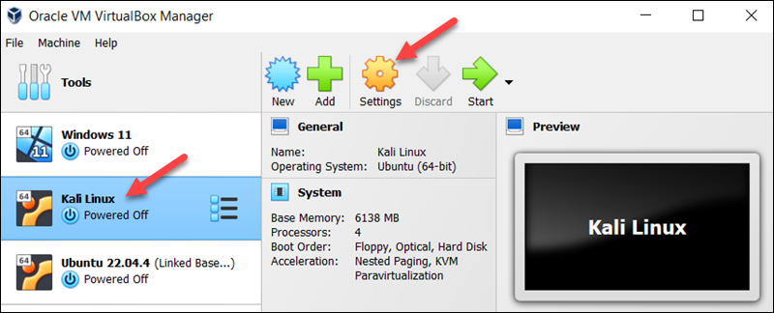

**Fig3(a)**

(b)Select the **Advanced** tab in the **General** section and change the **Shared Clipboard** and **Drag'n'Drop** settings to **Bidirectional**. This feature allows the host and the guest machine to exchange files.

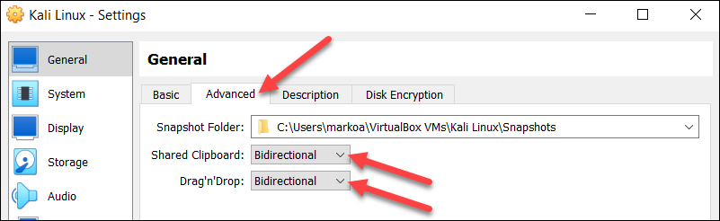

**Fig 3(b)**

(c)Select **Network** from the menu on the left side. Change the **Attached to** field to **Bridged Adapter**. Select **OK** at the bottom of the window to return to the main window.

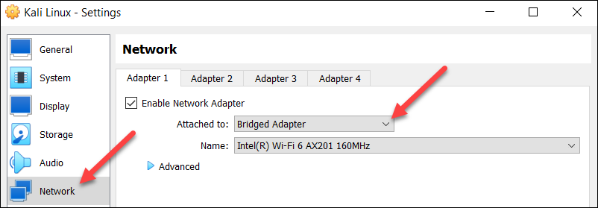

**Fig 3(c)**

(d)Click **Start** to begin installing Kali Linux.

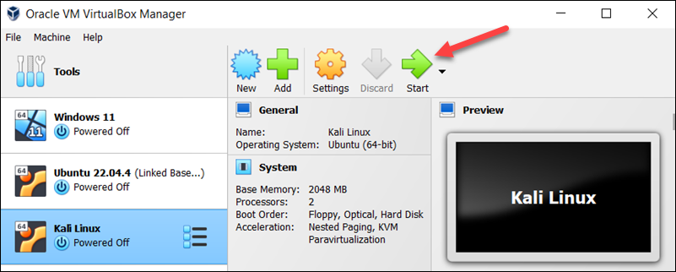

**Fig3(d)**

**Step 4: Perform Initial Configuration**

When the new VM is started, the Kali Linux installer menu appears. Start the installation procedure by following the steps below:

(a)Select the **Graphical install** option.

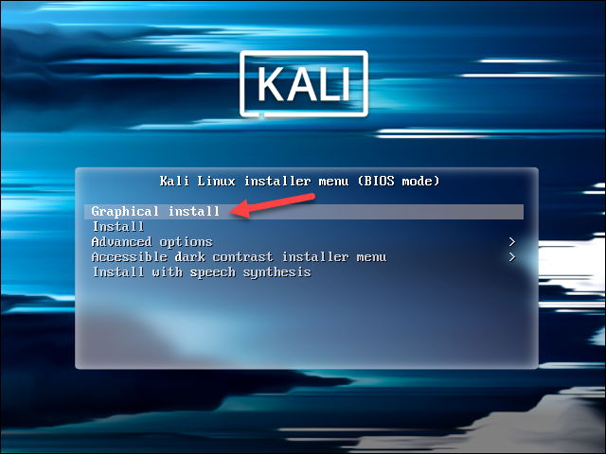

**Fig 4: Perform Initial Configuration**

(b)Choose the system's **default language**, which will also be used during installation.

(c)Find and select your **country** from the list or choose **other**.

(d)Decide which **keyboard mapping** to use.

**Step5: Configure Host, User, and Time Zone**

The following installer steps set up the hostname and domain of the system and configure the user:

(a)In the **Configure the network** section, enter a **system hostname**.

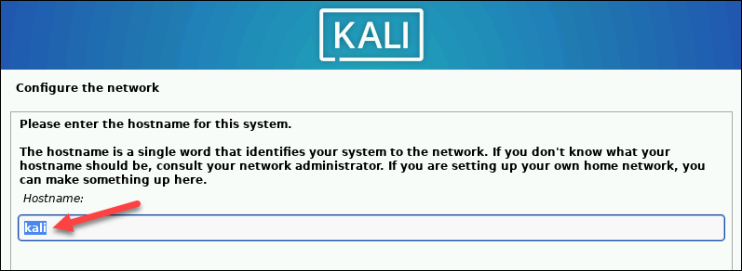

**Fig 5(a)**

(b)Type a **domain name** that the OS will use to identify the VM within a network. Specifying a [**domain**](https://phoenixnap.com/glossary/what-is-a-domain) name is not necessary if the VM is not part of an extensive local network.

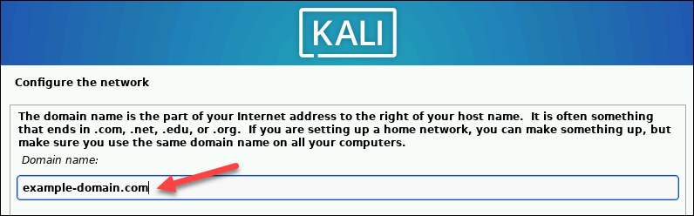

**Fig 5(b)**

(c)Create a **user account** by providing the user's full name and username.

(d)Create a [**strong password**](https://phoenixnap.com/blog/strong-great-password-ideas) for the user account.

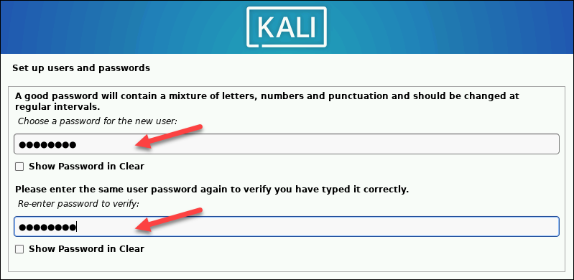

**Fig 5(d)**

(e)Select the correct **time zone** from the available options.

**Step 6: Create Hard Disk Partitions**

Proceed with the following steps to create a bootable partition on the virtual hard disk:

(a)Select how to partition the hard disk. The default option is **Guided - use entire** **disk**.

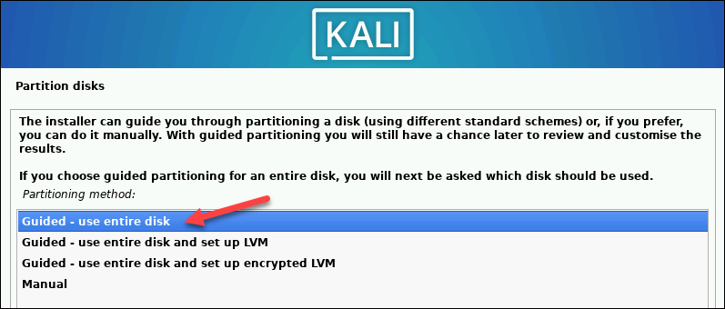

**Fig 6(a)**

(b)Select the disk you want to use for partitioning. The only available option is the disk created during the VM creation.

(c) Select the **partitioning scheme**. The default option is **All files in one partition**.

(d)The wizard provides an overview of the configured partitions. Ensure that the **Finish partitioning and write changes to disk** option is selected.

(e)Confirm the choice by selecting **Yes** on the next screen.

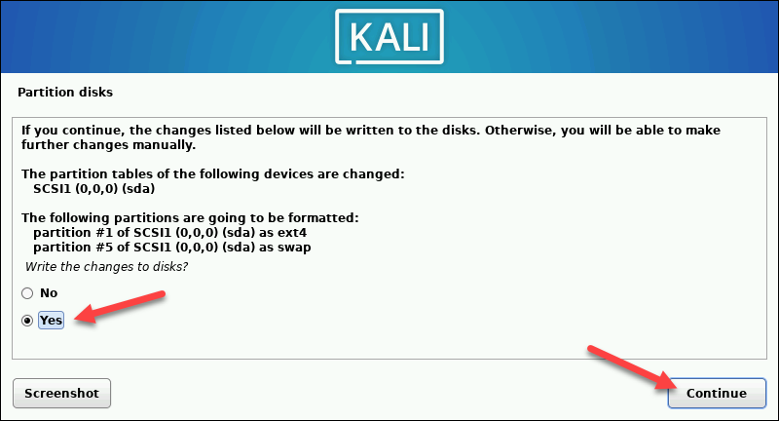

**Fig 6(e)**

**Step 7: Customize Kali Linux Installation:**

After installing the system's core, Kali enables users to customize the OS further. Choose the components to install by executing the following steps:

(a)Select the desktop environment and the tools you want or click **Continue** to proceed with the default options.

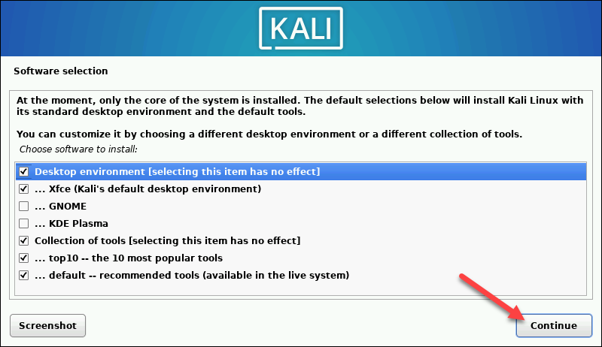

**Fig 7(a)**

(b)Select whether you want to use a network mirror.

(c)If you use an **HTTP proxy**, enter the necessary information. Otherwise, leave the field blank.

(d)Install**the GRUB bootloader** on the hard disk. Select **Yes** and **Continue**.

(e) Select a bootloader device to ensure the newly installed system is bootable.

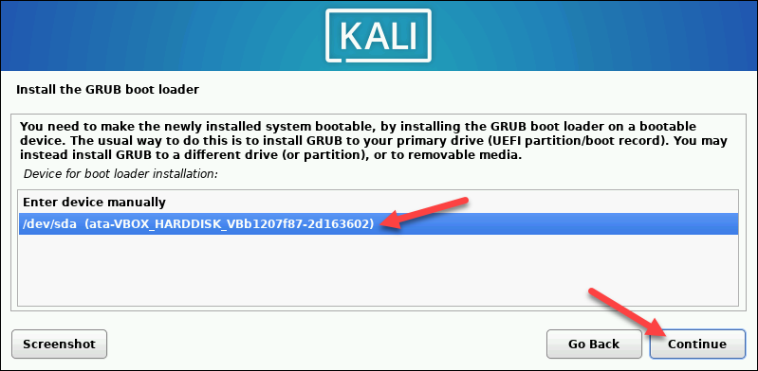

**Fig7(e)**

**When Kali finishes installing, the *Installation is complete* message appears.**

(f)Click **Continue**to reboot your VM. After rebooting, the Kali login screen appears.

(g)Enter the username and password created in the previous steps.

**The Kali Linux desktop appears on the screen.**

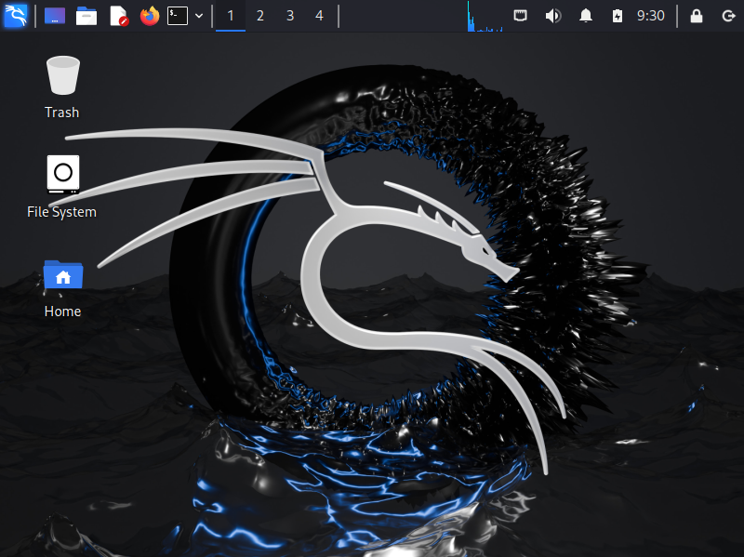

**Fig 8(The Kali Linux desktop appears on the screen)**